
Knowledge organiser – Climate Zones
What will we be learning?
- How to identify lines of latitude.
- The location of climate zones.
- Comparison of climates.
- The weather patterns in a climate zone.
- How to write a weather forecast.
- The characteristics of climate zones.
Key facts
The world’s climate zones:
Arid (hot and dry), Mediterranean (dry summers and mild, wet winters), Temperate (no extreme weather, with rainfall throughout the year), Tropical (high temperatures all year round, with lots of rain), Polar (a dry climate with very low temperatures).

Key knowledge
Climate is the average daily and seasonal weather patterns over a long period of time.
The Equator is an invisible line that runs around the centre of the Earth. The closer you live to the Equator, the hotter it is.
As the Earth is tilted on an axis, the Northern and Southern Hemispheres experience different types of weather at the same time of the year.
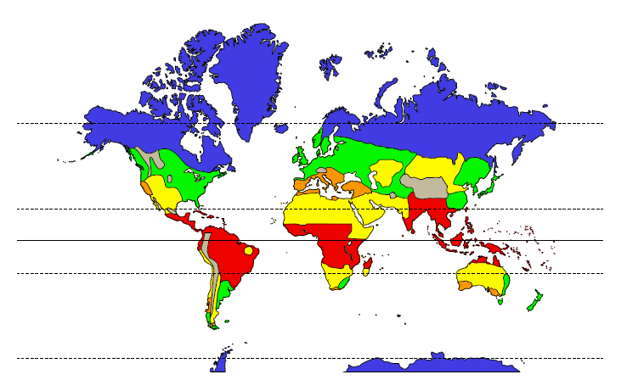
Arid
Mediterranean
Temperate
Tropical
Polar

Place names | Geographical terms and processes | Locational terms
Cairo (Egypt)  London (UK)  Manaus (Brazil)  Nuuk (Greenland)  Santiago (Chile)  Seville (Spain) | axis  meteorologist  orbit  precipitation (KS1 snow, rain)  temperature  weather station | Equator  latitude  map index  Northern Hemisphere  North Pole  Southern Hemisphere  South Pole
Glossary
climate: long-term weather patterns
climate zone: a part of the world where places have a similar climate (i.e. arid, Mediterranean, temperate, tropical, polar)
precipitation: rain, hail, fog, sleet and snow
weather: day-to-day temperature, wind, rainfall, etc

